**ROBOCHEF**

**A ROBOTIZED SYSTEM FOR ”CRUNCHY FRIT” FRESH FRIED FAST FOOD.**

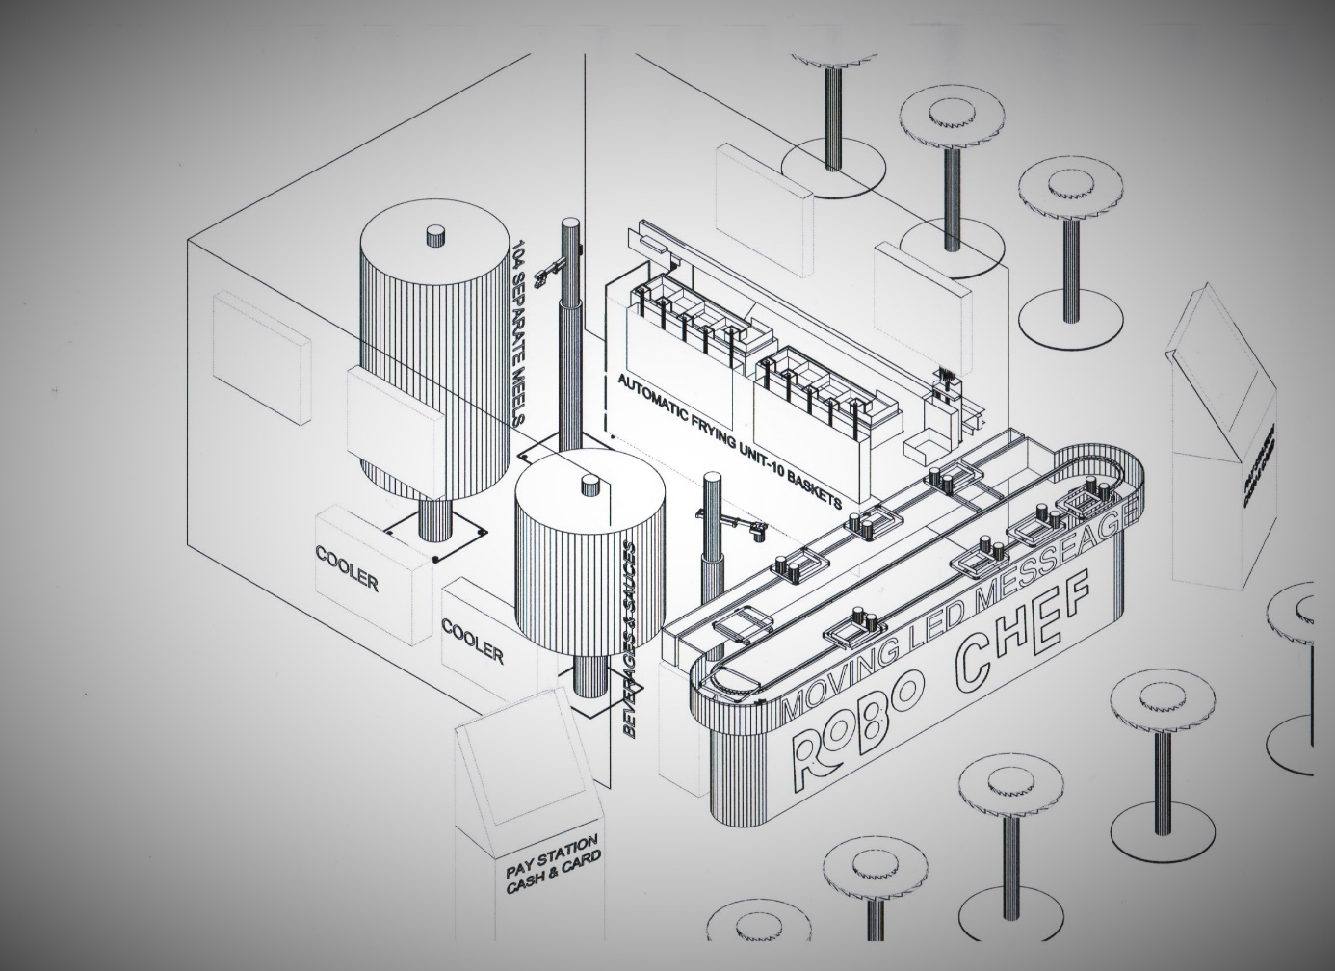

**BUSINESS PLAN**

**A ROBOTIZED FULLY AUTOMATIC SYSTEM FOR DELIVERING FRIED FOOD.**

ONE ORDINARY SYSTEM UNIT PROVIDES ONE COMPLETE , FRESH-FRIED MEAL WITH A BEVERAGE&IMPLEMENT EVERY **15-18 SECONDS**. MEAL PREPARATION TIME FROM ORDER TO DELIVERY WILL BE **2-3 MINUTES, DEPENDING ON THE MEAL**. REQUIRED STAFF=**1 PERSON**

* **MAIN AIM IS STARTING UP A NEW GLOBAL FAST FOOD CHAIN.**
* **AT THE CENTRE OF THIS CONCEPT IS THE ROBOCHEF SYSTEMS UNIT -A NEWLY DEVELOPED,** **ROBOTIZED FULLY AUTOMATIC FAST FOOD SYSTEM FOR FRIED FOOD.**
* **THE ROBOCHEF SYSTEM HAS BEEN DEVELOPED BY ARTENOBILE ENGINEERING LTD. info@artenobile.eu**
* INCLUDED IN THE BUSINESS PLAN IS **ALSO THE CREATION AND MANAGEMENT OF A SEPARATE BUSINESS UNIT FOR THE DEVELOPMENT AND** **PRODUCTION OF MEALS** SPECIFICALLY DESIGNED FOR PROCESSING AND DEEP-FRYING BY THE ROBOCHEF SYSTEM.
* MOST COMPONENTS IN THE ROBOCHEF SYSTEM ARE NEWLY DEVELOPED. THIS OFFERS ADDITIONAL POSSIBILITIES FOR **SEPARATE** MARKETING IN A SEPARATE COMPANY AND SALES ACTIVITY TO COMMERCIAL KITCHENS ,MILITARY UNITS,CRUISE LINERS,HOSPITALS AND MOBILE UNITS (EVENTS)

**DESCRIPTION OF THE ROBOCHEF SYSTEM**

**ORDERING AND PAYMENT** ARE MADE AT A PAY STATION EQUIPPED WITH TOUCHSCREEN, WHERE ALL MEALS, BEVERAGES AND IMPLEMENTS ARE PRESENTED. PAYMENT OPTIONS ARE CASH, CARD OR MOBILE.

**VISUALISATION** OF THE FOOD FRYING AND DELIVERY IS AN IMPORTANT PART OF THE ROBOCHEF CONCEPT. ON GOOD VISIBLE PLACES AND OVER THE DELIVERY DESK ARE A NUMBER OF TV-SCREENS SHOWING THE PROCESS THROUGH WEB-CAMS. SEE ALSO IN THE LATER SECTION ABOUT INTERNET MANAGED SCREENS AT THE DELIVERY TRAYS.

**AN APPEALING SCENT** (OF FOOD BEING COOKED) IS AN INTEGRAL PART OF THE MARKETING & PROMOTIONAL CONCEPT. ALTHOUGH THE PRODUCTION SYSTEM/ THE SYSTEMS UNIT IS EQUIPPED WITH AN EXCELLENT VENTILATION SYSTEM, SOME OF THE SUITABLE SCENT IS PLANNED TO BE CHANNELLED OUTSIDE OF THE ROBOCHEF UNIT TO ATTRACT NEW CUSTOMERS.

**FIRE SAFETY ABC**  IS PREINSTALLED IN THE UNITS VENTILATION SYSTEM.

**THE FRYING SYSTEM** CONSISTS OF SEPARATE OIL CONTAINERS WHERE EACH CONTAINER IS SEPARATELY HEATED, AND HAS TUBULAR FILTERS, ENABLEING CLEANING DURING OPERATION. OIL IS CONTINOUSLY CIRCULATED THROUGH THE CONTAINERS WITH SEPARATE OIL PUMPS. IN EVERY CONTAINER ARE 5 OR 6 SEPARATELY OPERATED FRYING BASKETS.

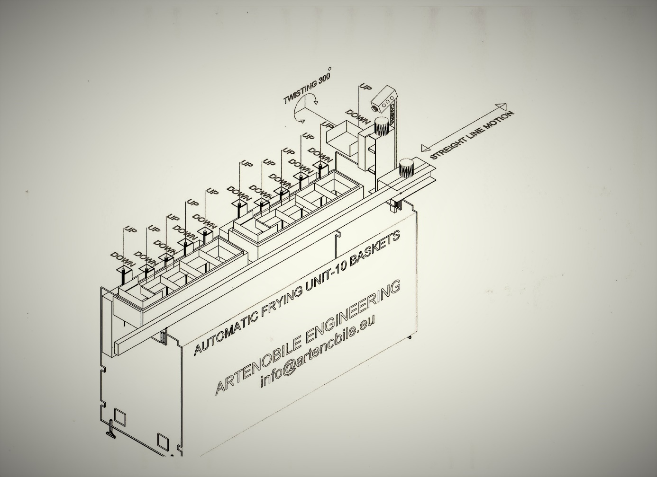

**THE ROBOTIC FRYING HAND** IS THE WORKHORSE OF THE SYSTEM. IT IS A ROBOTIC ARM WHOSE MOVEMENTS ARE COMPUTER CONTROLLED .WHEN THE ROBOTIC HAND HAS RECEIVED THE MEAL FROM THE LOADING UNIT (SEE DESCRIPTION BELOW) IT PLACES THE MEAL IN ONE OF THE FREE FRYING BASKETS ON STAND-BY.WHEN THE FOOD IS READY-FRYED, THE BASKET MOVES UP INTO THE UNLOADING POSITION FROM WHERE THE ROBOT HAND PICKS UP THE FRYED MEAL AND TRANSPORTS IT TO THE CUSTOMERS DESK.

**THE MEAL STORAGE UNIT** IS A REVOLUTIONARY, NEWLY DESIGNED AND DEVELOPED DEVICE TO STORE READY-MADE, SEMI-MANUFACTURED MEALS. EVERY MEAL IS PLACED ON A SEPARATE, STORING PLATE. 8-24 PLATES PER STORAGE PLATFORM. EVERY UNIT CAN STORE 208 MEALS OR MORE DEPENDING ON MODEL. EACH STORAGE UNIT IS SEPARATELY COOLED. THE MEAL PLATES ARE TAKEN THROUG A SLIT IN THE INSULATED COVER BY A TRANSPORT ROBOT CLASP WHICH HANDS OVER THE MEAL TO THE ROBOTIC FRYING HAND OF THE FRYING SECTION .THE EMPTY PLATE IS RETURNED TO THE STORAGE UNIT BY THE ROBOTIC ARM.THE STORAGE UNIT IS TO BE LOADED FROM THE REAR SIDE .**TO AVOID** PRODUCTION DOWN-TIME WHILE RE-LOADING IT,EACH ROBOCHEF UNIT CAN BE EQUIPPED WITH UP TO 3 REVOLVING STORAGE UNITS (DRUMS).WHEN THE FIRST STORAGE UNIT IS EMPTY, A NEW UNIT TAKES ITS PLACE. THE CHANGEOVER OF THE DRUMS HAS TO BE CARRIED OUT MANUALLY BY THE STAFF.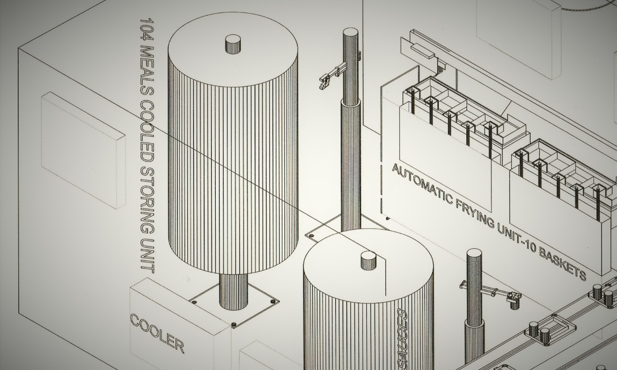

**BEVERAGE AND CONDIMENT STORING UNIT** IS WORKING AT THE SAME PRINCIPELS AS THE MEAL STORING UNIT.FURNISHING AND SIZE CAN BE DIFFERENT.

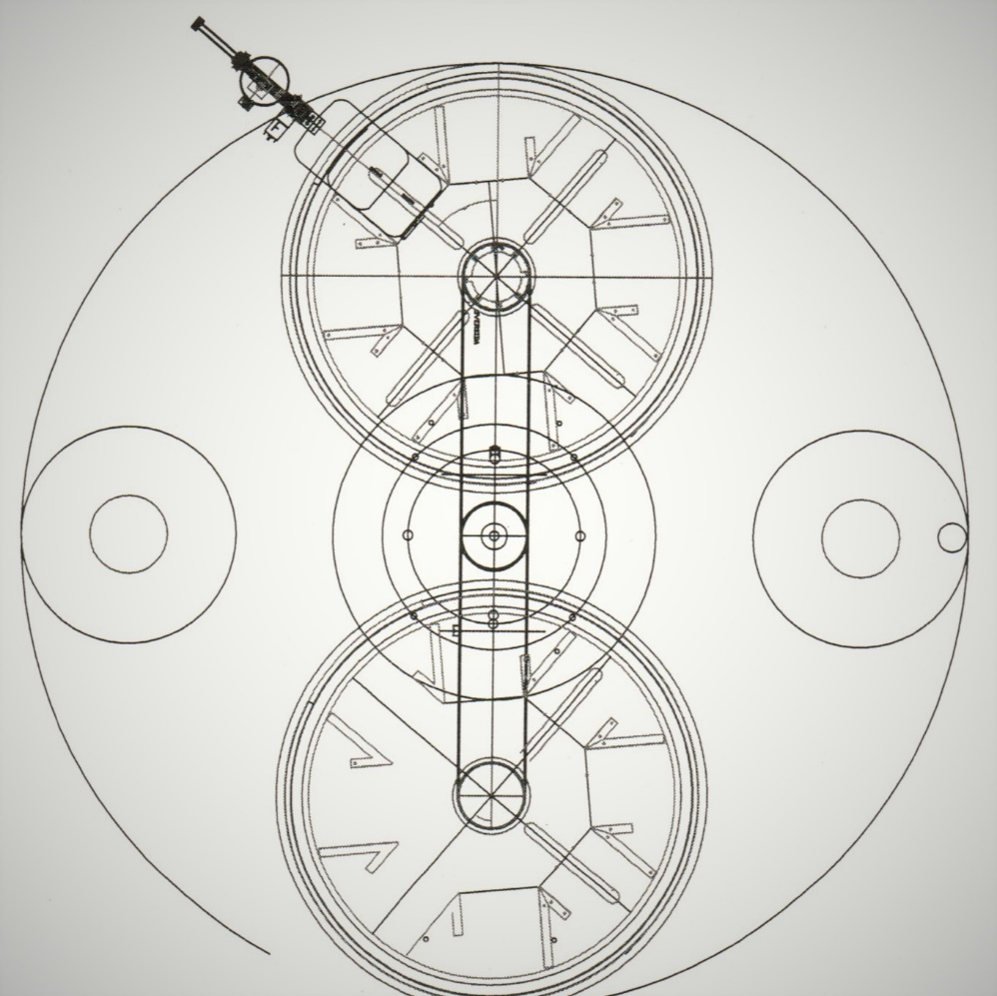

**TRANSPORT ROBOT** CLASP ARE SERVICING THE MEAL AND BEVERAGE STORING UNITS. THEESE NEW DEVELOPED ROBOTS WITH 3-4 DEGREES OF FREEDOM ARE FITTED TO THE STORING UNITS. **THE** TRANSPORT ROBOT GRASPS THE STORING PLATE, PULLS IT TO THE FRYING ROBOT HAND,TILLTS THE PLATE –TRANSFERS THE MEAL –RETURNS WITH THE PLATE AND PUSHS IT BACK TO THE MEAL STORING UNIT. THE TRANSPORT ROBOT FOR BEVERAGE AND IMPLEMENT HAS THE SAME FUNCTION BUT BEVERAGE AND IMPLEMENT CAN BE CLAMPED DIRECTLY IN ITS OWN PACKAGING.

**DELIVERY DESK/CONVEYOR** **FOR DELIVERY TRAYS** IS THE DIRECT CONTACT BETWEEN CUSTOMER AND ROBOCHEF SYSTEM. LENGTH AND FORM CAN BE VARIED. THE UPPER FRONT OF THE DESK-FACING CUSTOMER - CAN BE EQUIPPED WITH A MOVING LED TEXT.LOWER FRONT OF DESK IS MADE OF AN OPAK SEMI TRANSPARENT MATERIAL WHICH CAN BE ILLUMINATED IN DIFFERENT COLOURS.THE DESK CAN BE DIVIDED (LONGITUDINAL AXIS) WITH A GLASS WALL BETWEEN DELIVERY AND SERVICE PART. ON DESK TOP IS A LOOP OF CHAIN-CONVEYOR WITH TWO DRIVE CROSSINGS TO A STRAIGHT LINE CHAIN-CONVEYOR. LOADED TRAYS ARE TRANSPORTED ON THE LOOP UNTIL MEAL IS TAKEN. EMPTY TRAYS ARE TRANSPORTED TO THE STRAIGHT CHAIN-CONVEYOR AT UPPER CROSSING AND FILLED TRAYS BACK TO THE LOOP THROUGH THE LOWER CROSSING. DELIVERY POSITIONS ARE SITUATED ON THE STRAIGHT LINE CONVEYOR. FIRST CRUNCHY BOX, (PAPER PULP TRAY) THEN BEVERAGE& INPLEMENT AND FINALLY THE CRUNCY MEAL IS LOADED ON THE TRAY WHICH CAN BE EQUIPPED WITH COVER.

**CRUNCHY BOX** IS A NEW DEVELOPED MOULDED PAPER PULP CONTAINER WHICH ENABLES CUSTOMERS TO CATCH ORDER WITH ONE HAND. SPEEDS UP THE DELIVERY SYSTEM AND INCREASES THE SECURITY WHILE CUSTOMERS OTHER HAND IS FREE FOR BAG OR LUGGAGE. IF CUSTOMER WISHES ”TAKE AWAY” A COVER TO THE PAPER PULP CONTAINER IS AVALIABLE IN THE CUSTOMERS DESK.

**DELIVERY TRAYS** BELONG TO THE CONVEYORSYSTEM. THE DESIGN AND FINISH OF TRAY IS AN IMPORTANT PART OF MARKETING. WE HAVE DEVELOPED TO COMBINE TRAYS WITH COMPUTER SCREENS TO INFORM CUSTOMERS ORDERNUMBER AND INCRESE THE EFFECT OF MARKETING WHILE THE TRAY IS IDELING.COMPUTER SCREENS WORK WITH CENTRAL ROUTER TECHNIQUE.

**VISUAL AND TECHNICAL CONTROL** OF THE ROBOCHEF SYSTEM IS MADE BY SCREEN INSIDE THE ROBOCHEF UNIT CONNECTED TO WEB-CAMS AND THE COMPUTER CONTROL SYSTEM.

**EXTERN GLOBAL CONTROL OF SYSTEM** AND SYSTEMS ARE POSSIBLE IN REAL TIME THROUG INTERNET CONNECTIVITY.DIRECT OBSERVATION REGARDING ALL INCOMING AND OUTGOING VALUES AND WEB-CAMS. **SUPERWISER** SHAL BE ABLE TO CONTROL,RECOMMEND, INTERVENE, HELP OR GUIDE.

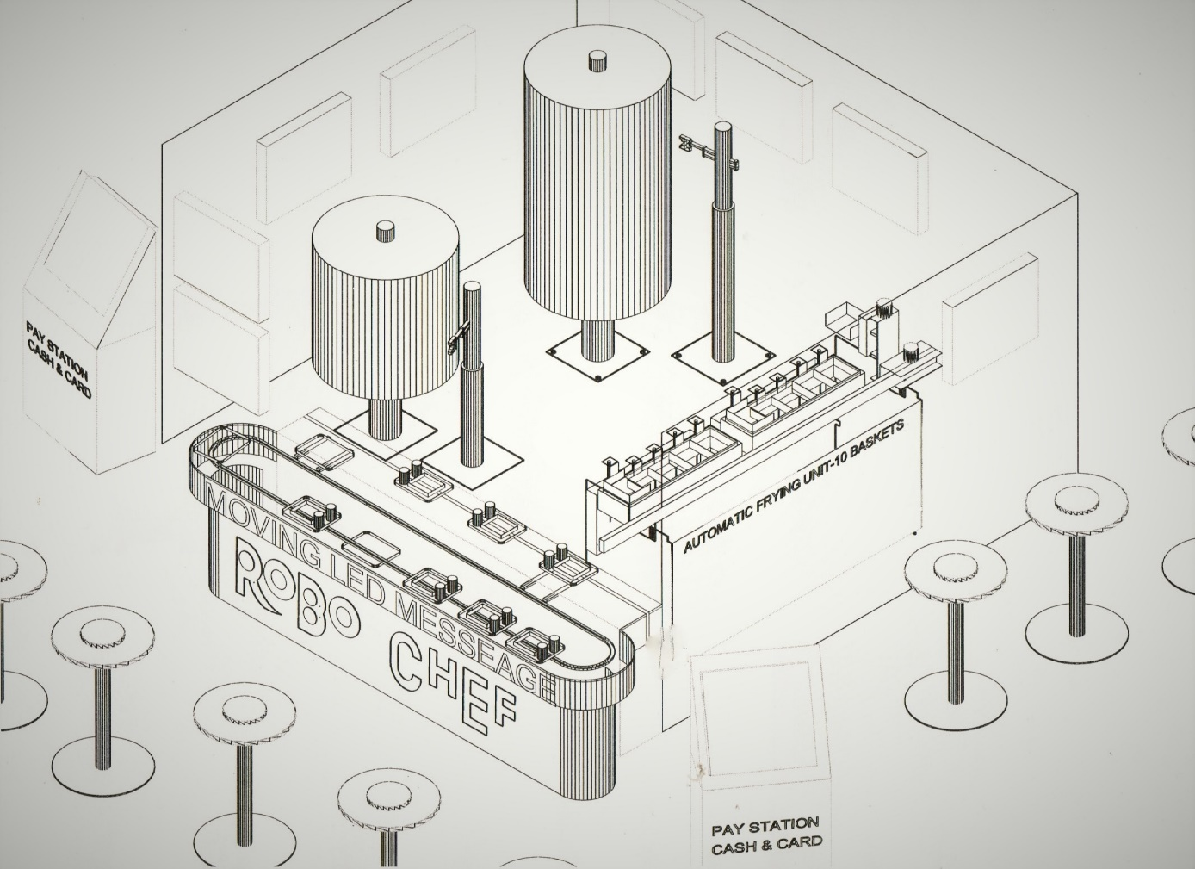

**CALCULATION OF TURNOVER** ONE ROBOCHEF UNIT DEPENDING OF WHERE THE UNIT IS SITUATED. THEORETICAL ONE UNIT **CAN DELIVER 200-240 MEALS PER HOUR** WITH BEVERAGE AND SUPPLEMENT PER HOUR.

**ROBOCHEF CONCEPT IS ADRESSED TO EVERYBODY** . THEREFOR BEVERAGE CAN INCLUDE (DEPENDING OF LAW ) WINE AND OTHER ALCOHOLIC AND/OR NON ALCOHOLIC BEVERAGES.

**MEALS** CAN BE IN MANY PRICE RANGES. FROM FRITTED LOBSTER/SHRIMPS WITH SWEET SOUR SAUCE TO FRITTED POTATO CROQUETTE/POMMES FRITTES WITH MAYONESE.

**WE ESTIMATE A LUNCH** WITH MEDIUMPRICED FOOD- WITH BEVERAGE - GIVES APPROXIMATELY **12 EUROS PER** CUSTOMER. **50%** OF DELIVERY CAPACITY MEANS **960** MEALS PER 8H.TURNOVER IN THIS CASE IS **11.520 EURO** PER 8 HOURS.

**WE HAVE MADE A CALCULATION EXAMPLE** BELOW WITH  **ONLY 300 MEALS** PER 8H. NIGHT ONLY **200** MEALS.(CORRESPONS TO **800 MEALS** A 24 H)

* **CALCULATION ROBOCHEF .**

1.ROBOCHEF ASSET.5Y 200.000 **YEAR** 40.000  **MONTH** 3.330.00

2.LOCAL RENT 100.000 8.300.00

5000E/M2X20=100.000

3.STAFF COST 2 PERSON (16H) ( 48.000 4.000.00)

” ” 3 PERSON (24H) 72.000 6.000.00

4.ELECTRICITY+INTERNET 24.000 2.000.00

5.PART OF COMMUNITY 24.000 2.000.00

6.BANK & ADMIN 24.000 2.000.00

……………………

**284.000.00 23.630.00**

**SELLING 24.000 MEALS PER MONTH-IS 800 MEALS/DAY=33 MEALS/H**

**CORRESPONDS TO 288.000,00 TURNOVER PER MONTH**

**COSTS /MONTH/AS PER ABOVE 23.630,00**

**MEAL PROFIT PR PC.=4,8 EURO**

**MEAL PROFIT PER MONTH: 115.200,00 (YEAR 1.382 400,00)**

**PROFIT PER YEAR ON ONE UNIT 1.098400,00**

MEAL COST INKL FREIGHT 6 EURO

MEAL VAT 1.24

THIS CALCULATION SHOWS **APPROX.1 MILLON EURO PROFIT** PER YEAR IF ONLY **800 PC** MEALS ARE SOLD PER **24 HOUR**. **PLEASE NOTE** THE ”LOCAL RENT” IS CALCULATED ON **5000 EURO PER SQUARE METER/YEAR** FROM PRICE IN BEST WALKING STREET IN MUNICH. **IN EXAMPLE ABOVE** THE ROBOCHEF UNIT IS **MANNED 24 HOURS** A DAY.

ROBOCHEF UNITS ARE MENT TO BE AT THE MOST FREQUENTED PLACES AS **AIRPORTS, RAILWAYSTATIONS** AND **TOWN CENTERS**. BECAUSE OF THE SMALL SIZE AND HIGH CAPACITY OF ROBOCHEF, MOBILE SYSTEMS CAN MAKE HUGE PROFITS AT EVENTS, AS SPORT AND MUSIC FESTIVALS.

ROBOCHEF CONCEPT IS RECENTLY DEVELOPED THEREFORE OUR WEBSITES ARE UNDER CONSTRUCTION.

**AN ANIMATED VERSION OF ROBOCHEF SYSTEM IS AVALIABEL.**

**ARE YOU AS INVESTOR INTERESTED?-ASK FOR OUR LETTER OF INTENT** **AT** [info@artenobile.eu](mailto:info@artenobile.eu)

[www.robochef.info](http://www.robochef.info)

[www.robo-chef.eu](http://www.robo-chef.eu)